AME532a Second Proposal Report

Jiaoran Wang

6205909903

Contents

Abstract 2

Chapter 1: Introduction 3

Chapter 2: ASW28 Flight Control System 4

2.1 State Equations 4

2.2 Overall Control System 5

2.3 Controller Design 6

3.1 Autopilot Controller Concepts 6

Chapter 3: Model Trim and Linearization 10

1 Model Trim 10

1.1 Model Trim (without aero surface) 10

1.2 Model Trim (with aero surface) 11

2 Model Linearization 12

3. Perfect Linear States 13

Chapter 4: ASW28 Flight Dynamic Analysis 14

4.1 Introduction 14

4.2 XFLR5 Dynamic Analysis 14

4.2.1 Model Design 14

4.2.2 Dynamic Coefficient Calculation 15

4.3. ANSYS Dynamic Analysis 16

4.3.1 Finite Element Analysis 16

4.4. Results Comparison 17

4.4.1 Fuselage Analysis 17

4.4.2 Method Differences 17

4.4.3 Aerodynamic Parameter Distribution 17

4.5 Conclusions 17

Chapter 5: Simulation 18

5.1 Connection to FlightGear 18

5.2 Lateral Motion Control 18

5.3 Long Motion Control 18

Conclusions 19

References 20

Useful links 21

Abstract

The aerodynamic model of this report is based on the data of ASW28 model and 12 equations of steady state. The research objectives are the design of model control system and the basic aerodynamic analysis. Firstly, the system block diagram is built as well as controllers applied using MATLAB & Simulink. Secondly, the dynamic analysis results from XFLR5 and ANSYS FLUENT are compaired to enhence the comprehension of flight dynamics and also optimize the dynamatic coefficients in control systems. Finally, the block diagrams connect with FlightGear for the controller simulation display.

Chapter 1: Introduction

This report uses ASW28 model for base model calculation:

Figure 1-1. ASW28 Data

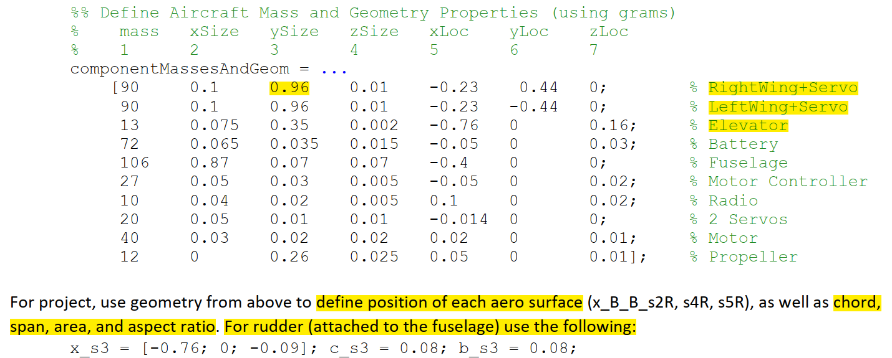

Chapter 2: ASW28 Flight Control System

2.1 State Equations

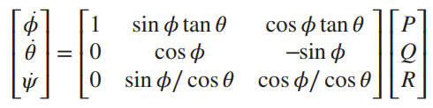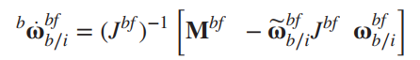

Figure 1-1. Control System

**(2-1)**

**(2-2)**

**(2-3)**

**(2-4)**

The above figure shows the 12 state-equations which are the base of control system.

Or maybe this? The flat-Earth equations of motion:

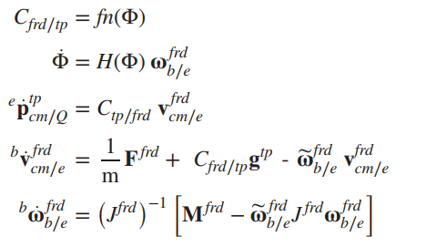

Figure 1-1. Control System

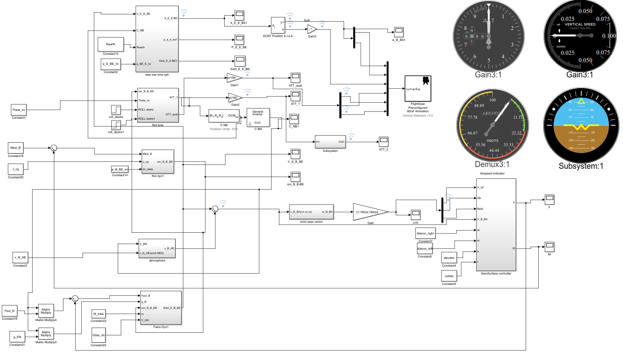

2.2 Control System Design

2.2.1 Overall System

The dynamic control system contains five sub systems: Translational Kinematics & Dynamics, Rotational Kinematics & Dynamics and Aero Surface. Most of the imported parameters are calculated outside the Simulink blocks in order to reduce the number of systems calculating steps.

2.2.2 Aero Surface Controller Design

The CL_s could be adding the aero surface infections according to the blocks

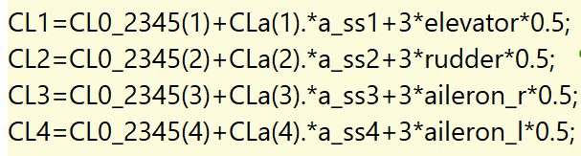

Figure 1-1 Full Span Control Surface coefficient

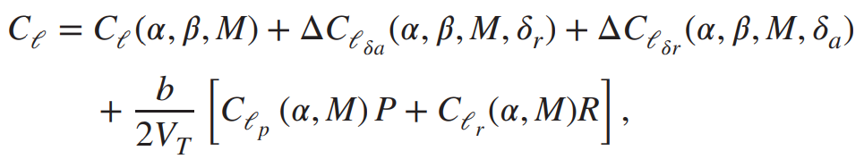

Figure 1-1. Aero Surface Controller

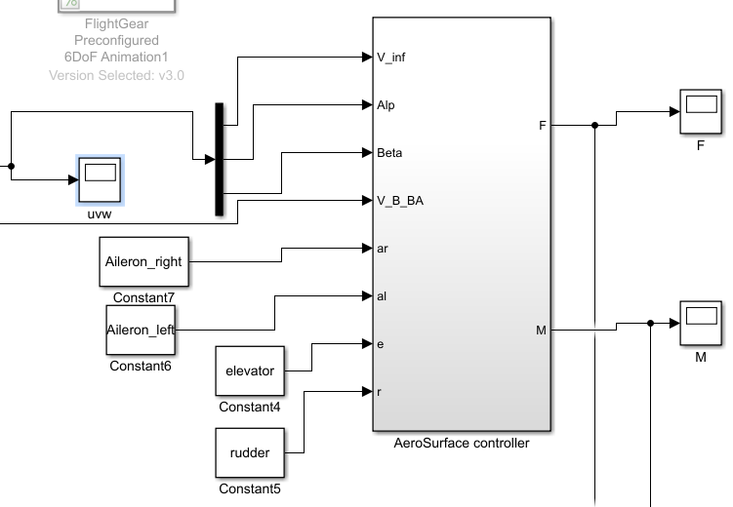

2.3 Controller Design

2.3.1 Autopilot Controller Concepts

The figure shows how autopilot control system works by using inner and outer feedback loop to control ailerons then reach desired roll positions. Following the same principle, we could

Figure 1-1. Autopilot Roll Angle Control Design

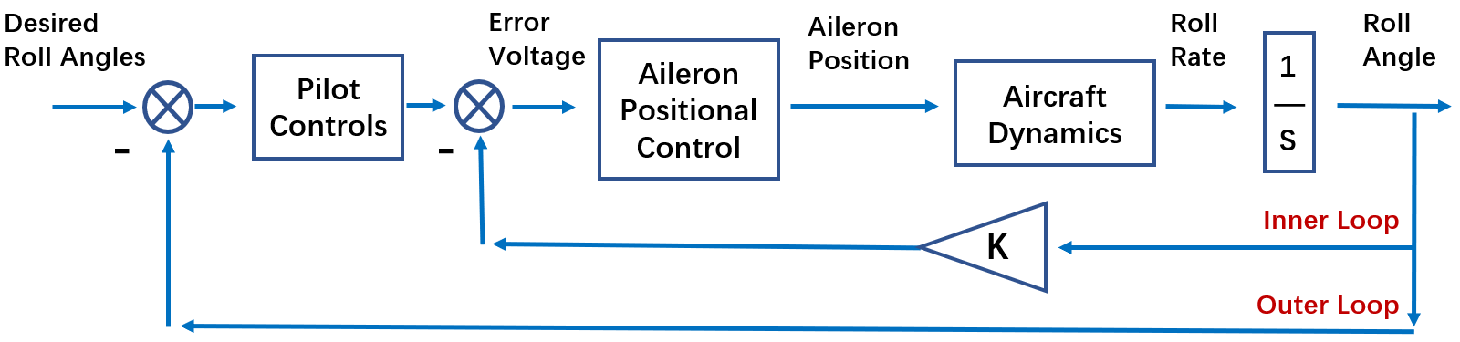

design different controllers for elevator to control pitch and rudder for yaw angles, in which case, the aero control system is added into the system. Besides, the parameters (such as V_inf) should change in real time.

1) Rolling Moment

Rolling moments are created by sideslip alone, by the control action of the ailerons and the rudder, and as damping moments resisting rolling and yawing motion.

After applying the aero surface into the blocks, the inner force and moment will change in real time.

Figure 1-1 Real Time Inner Force and Moment

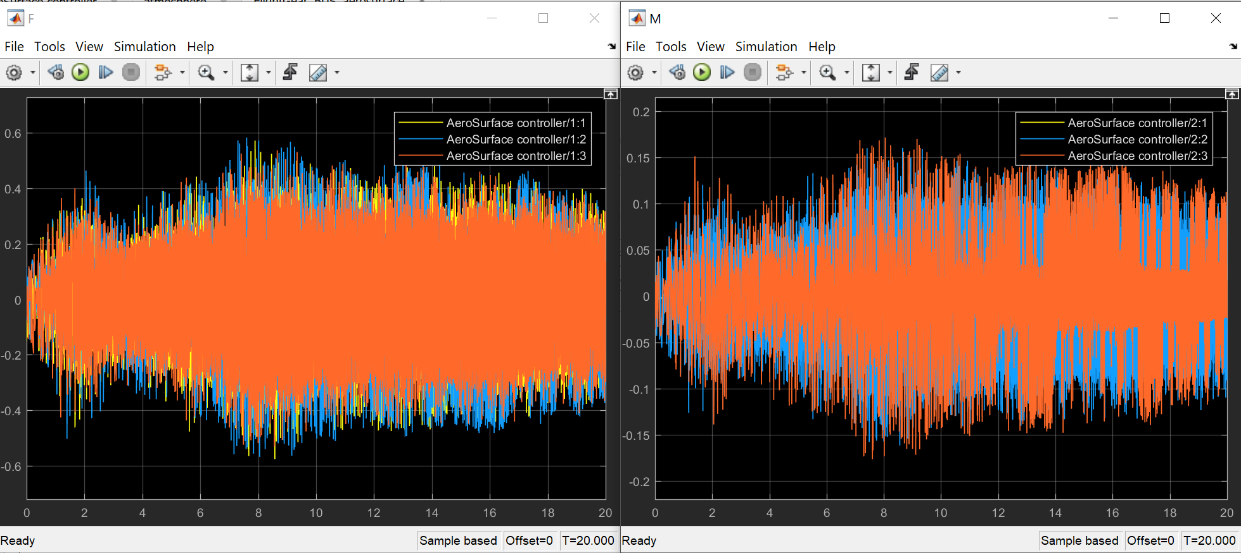

2.3.2 PID controller design

1) PID in Rotational Kinemics loop

Inside Rotational Dynamics, The PID controller is set up to eliminate the flight tremor during the cruising flight. Enlightened by autopilot block design in simulation, the PID controller is applied before Euler angle changed along the rotational rates in Body system respect to Earth reference frame. By using PID tuning system, the pitch and yaw offset curve could be trimmed

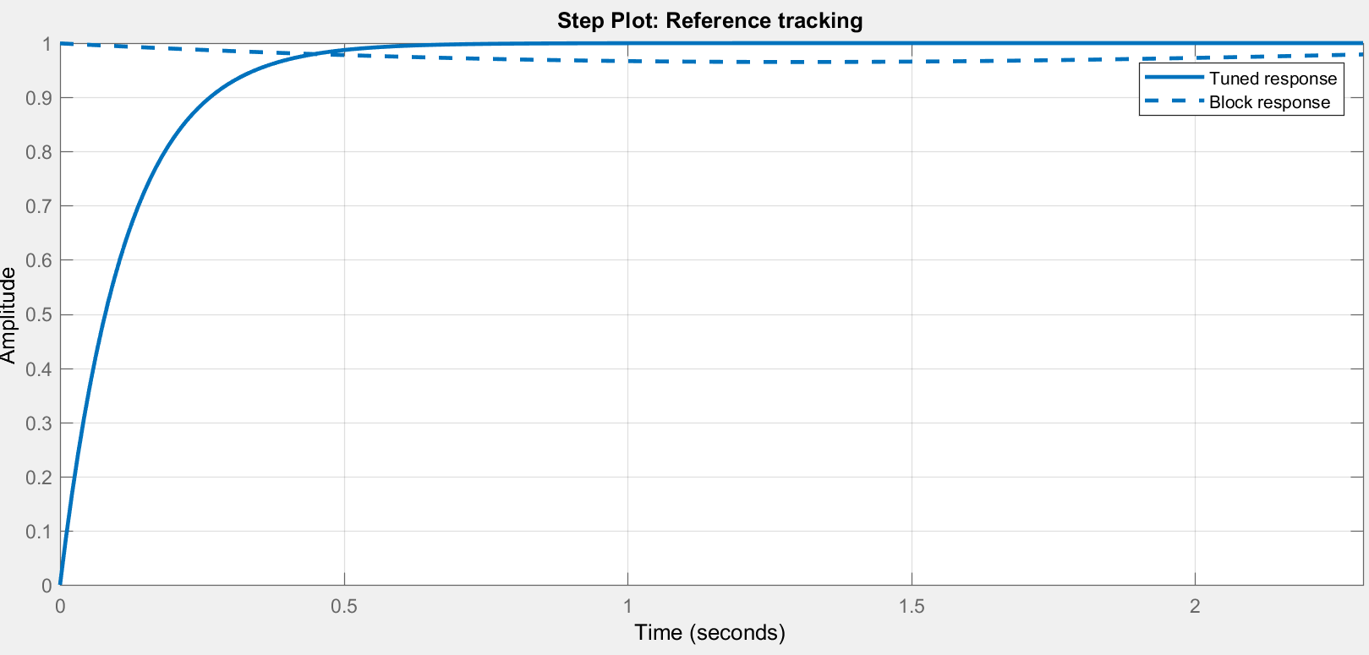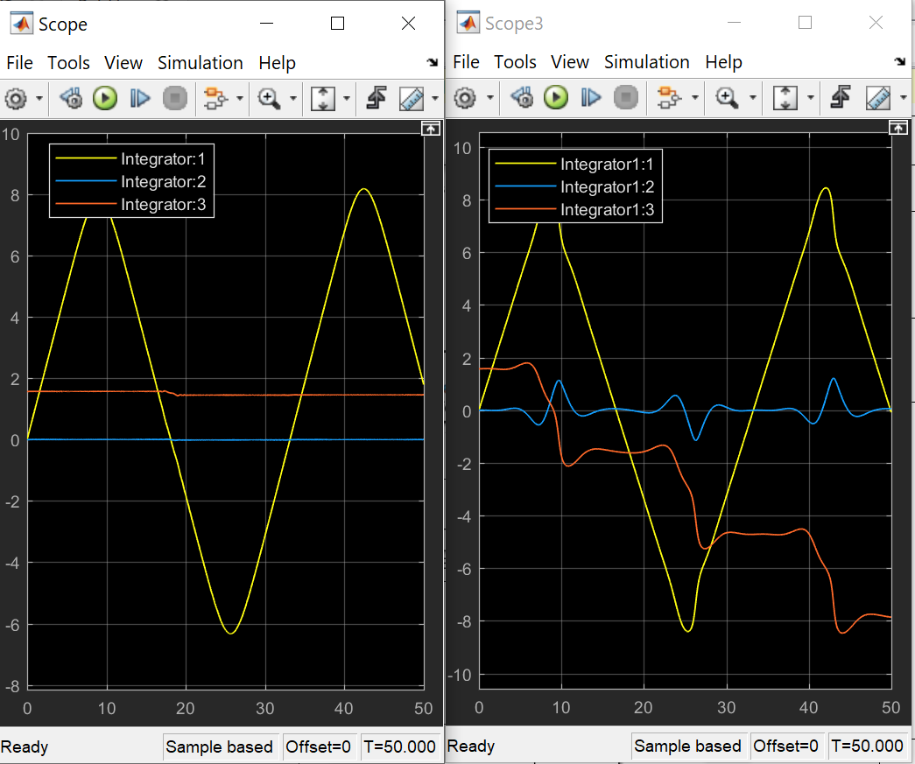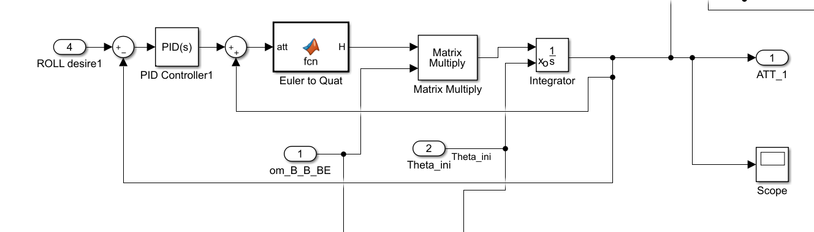

Figure 1-1. PID Controller Design for vibration elimination

2) PID for Single Angle Design

Yaw angle tuned

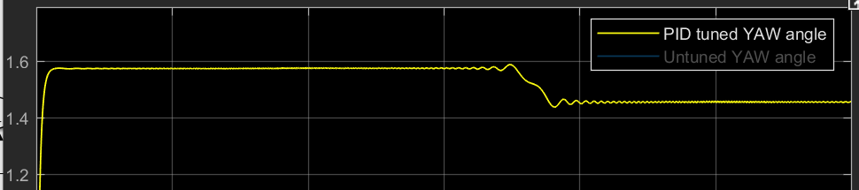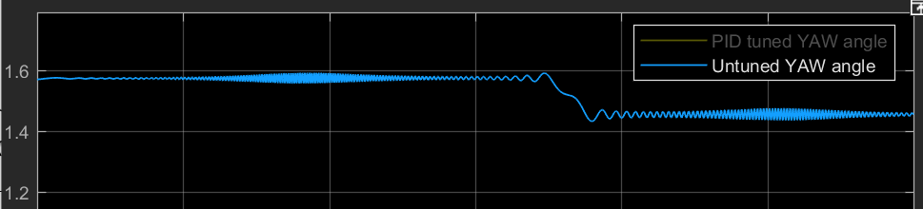

Figure 1-1. PID Controller Design for vibration elimination

3) Separate PID controller Design (Failed)

The three angles are coupled then I tried to use the separate:

Could not decouple them

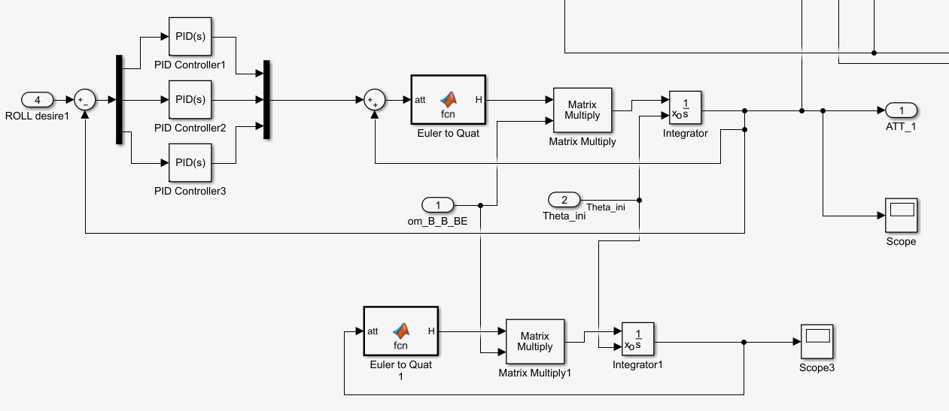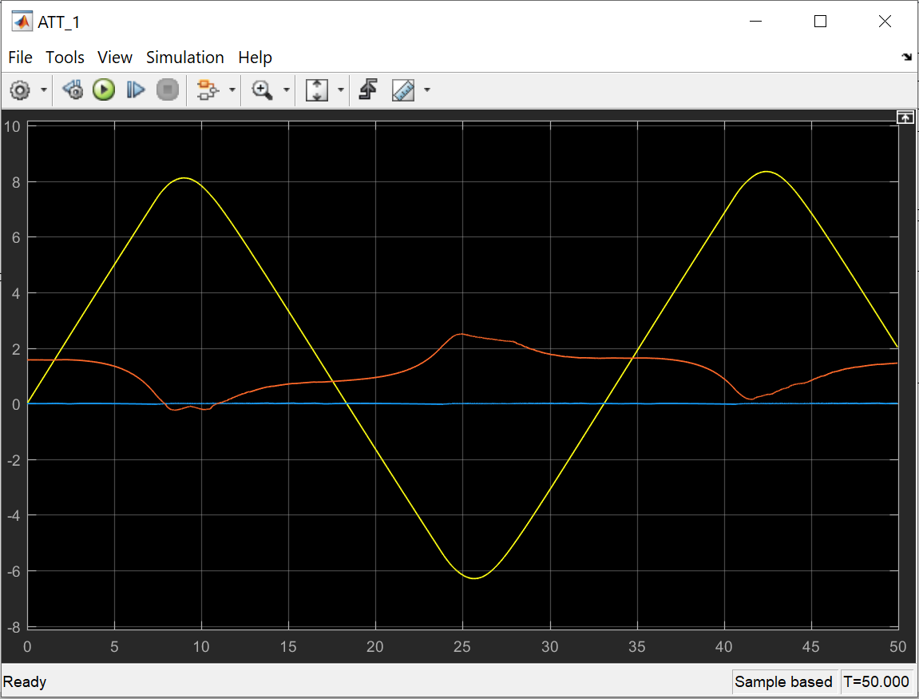

Figure 1-1. Control System

Chapter 3: Model Trim and Linearization

3.1 Model Trim

By using Linear Analysis in Simulink, the twelve states could be trim to linearize the outputs. After discussing with teammates, we decide to trim these seven states: [Alt, Phi, Psi, V, P, Q, R]

3.1.1 Model Trim (without aero surface)

The results are showed below. The trimmed states are much linearized than untrimmed one. To be more particularly, the final simulation results have changed.

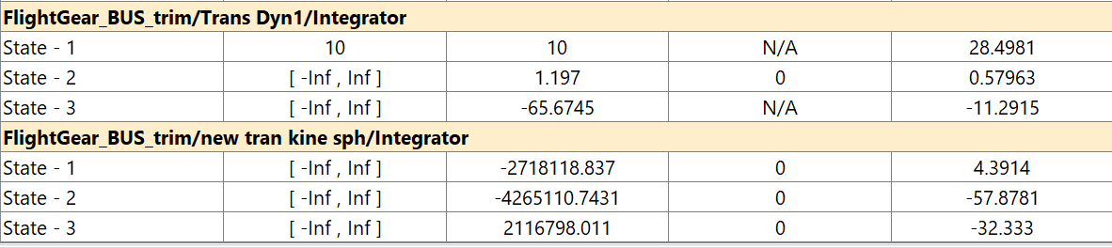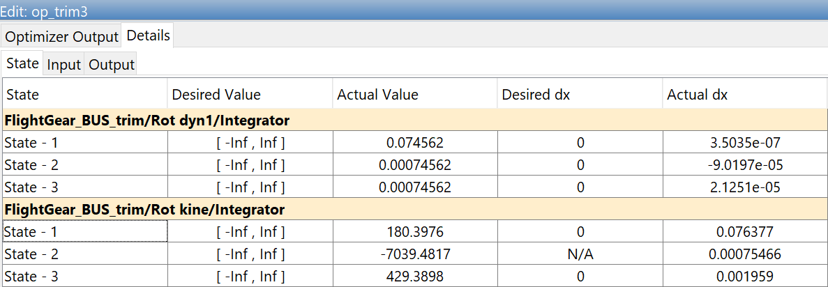

Figure 1-1. Linear Analysis Trim States

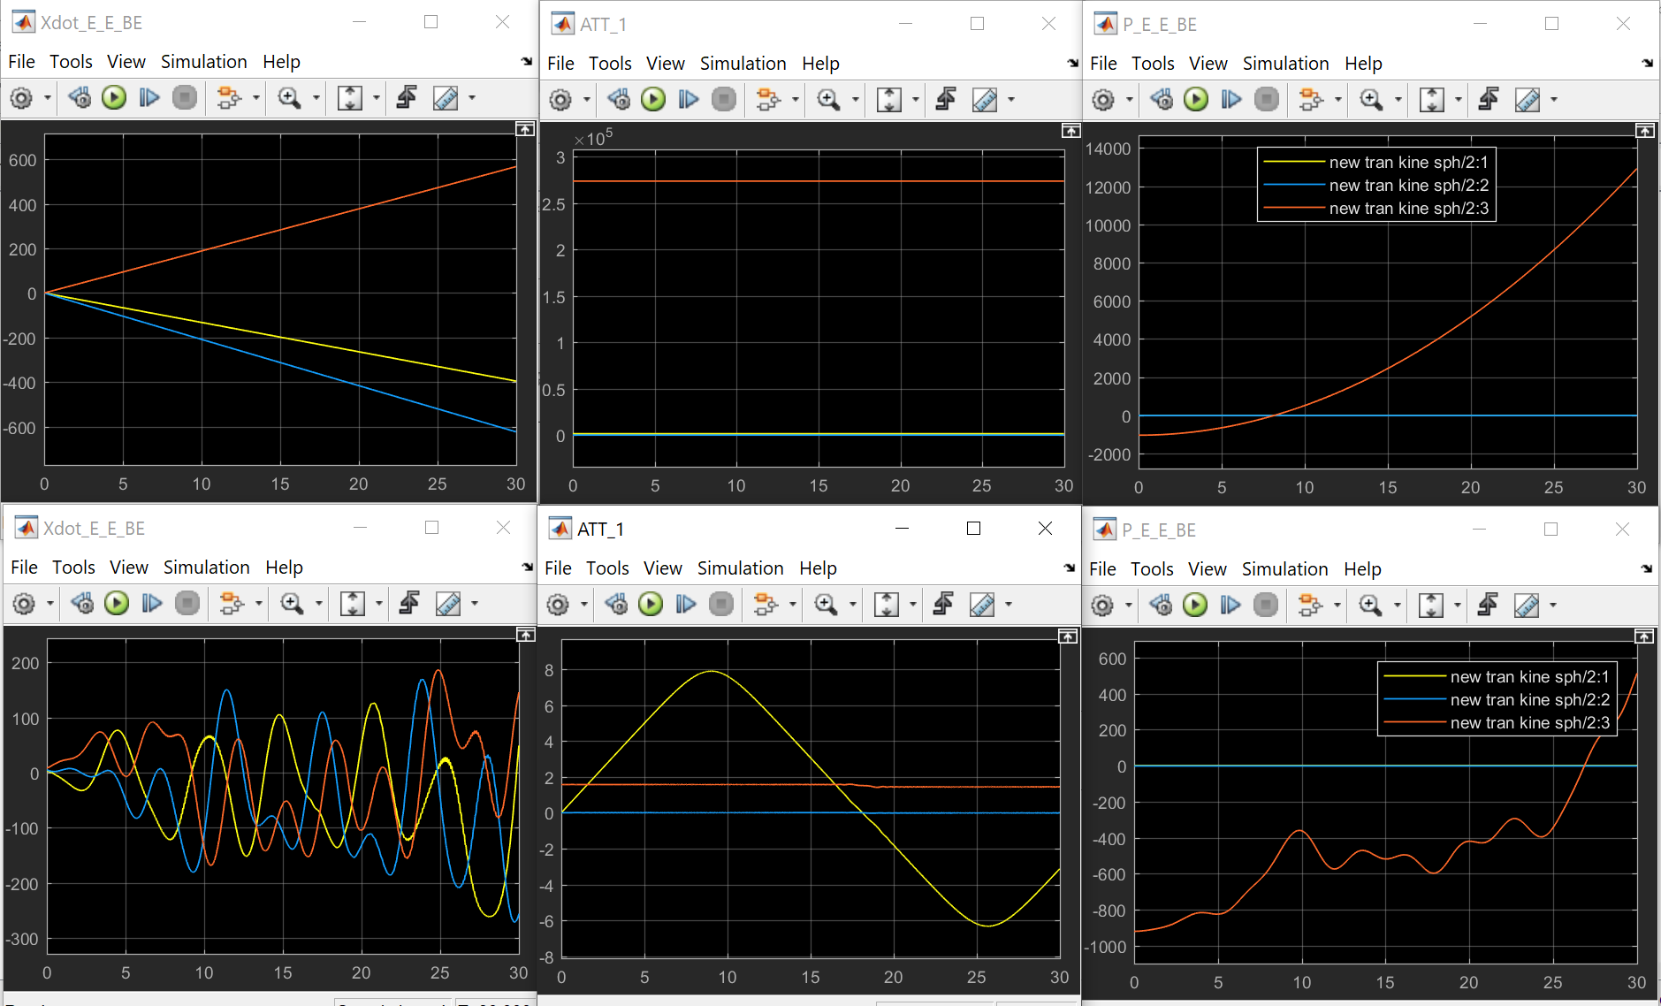

Figure 1-1. Trim Results (up: trimmed; down: untrimmed)

3.1.2 Model Trim (with aero surface)

After I apply the aero surfaces into the system:

Figure 1-1. Trim Results (up: trimmed; down: untrimmed)

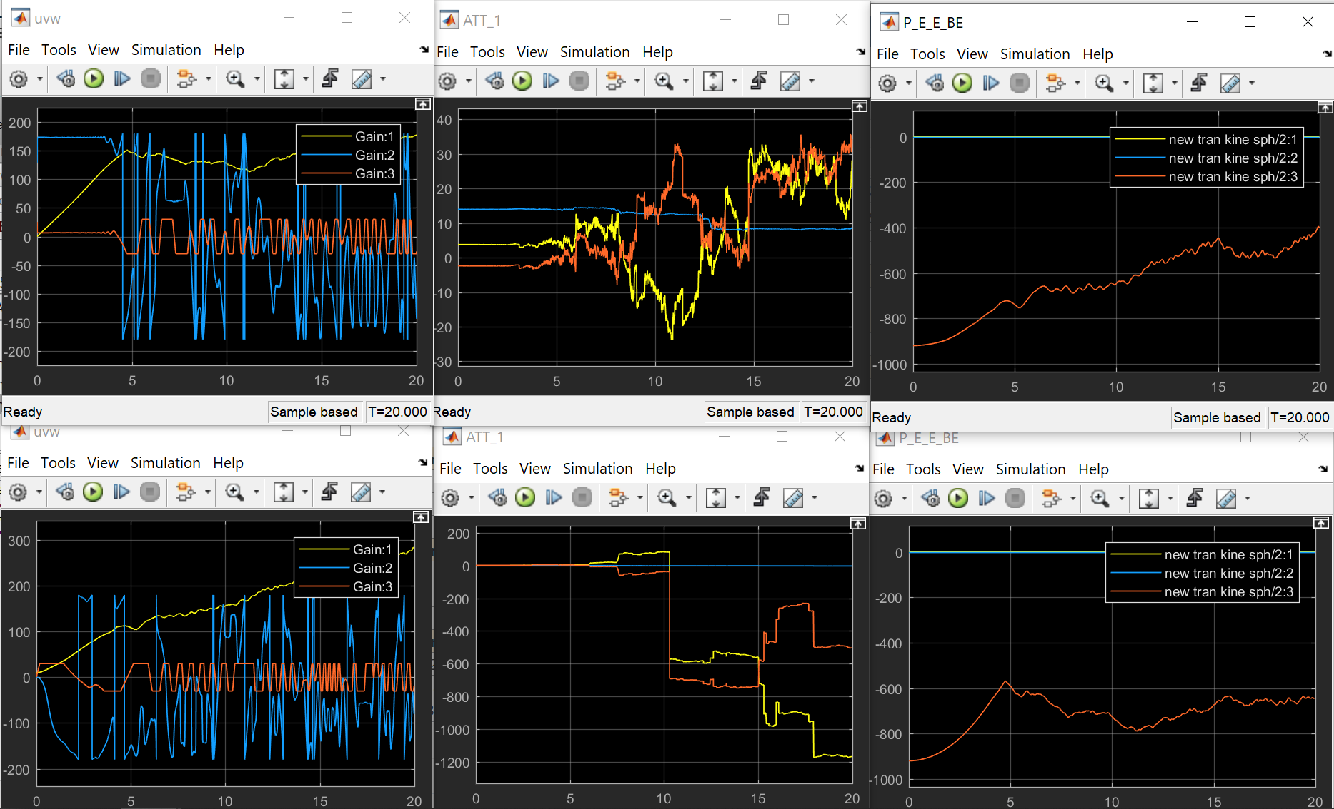

3.2 Model Linearization

3.2.1 Rotational Kinemics System Linearization

The linmode() in Simulink should

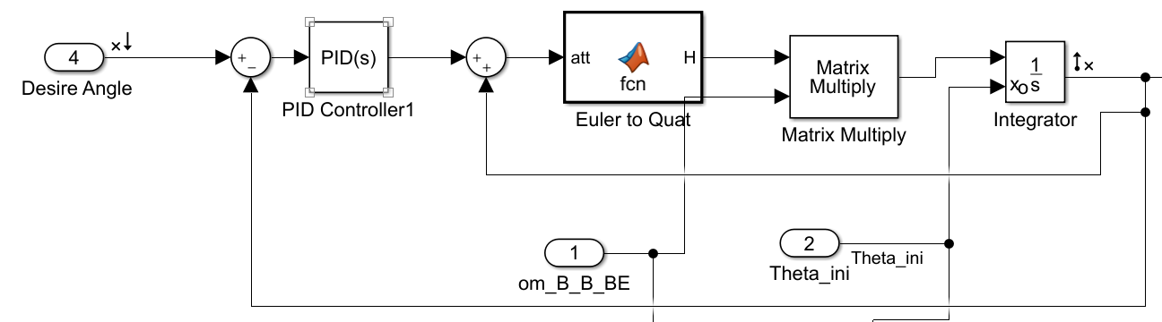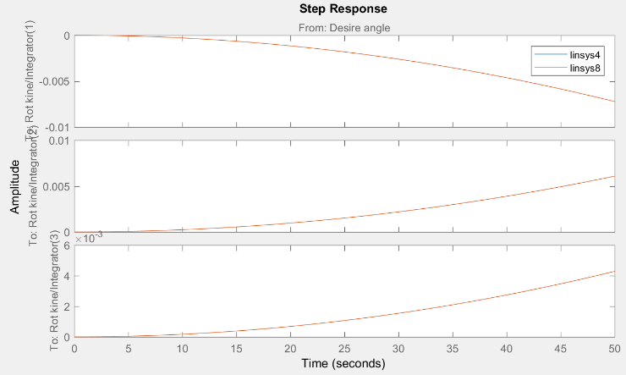

3.2.2 Full System Linearization

3.3 Linear States Analysis

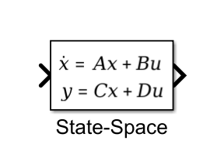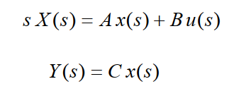 3.3.1 Aircraft Dynamic Stability Analysis

A simple analysis of a generalized multiple-input-multiple-output (MIMO) system is using Laplace transform for the state space system(left) and setting the feed forward term to zero (right)

Figure 1-1. Trim Results (up: trimmed; down: untrimmed)

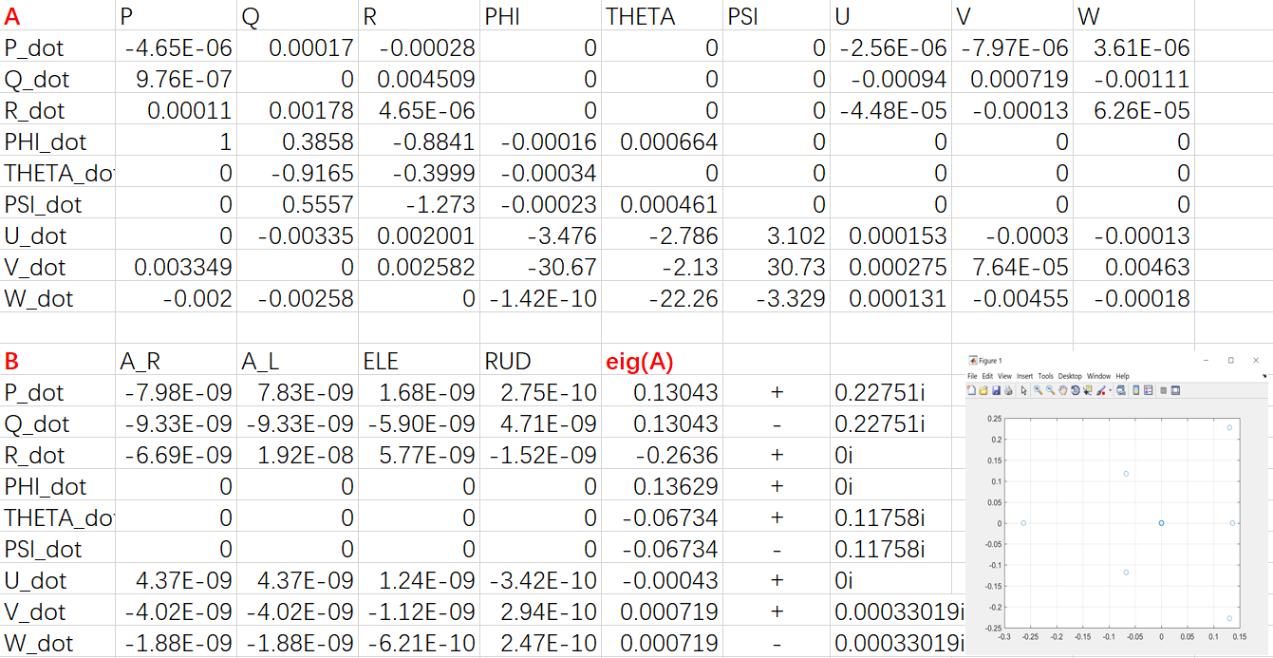

**1) Dutch Roll Mode**

Through the eigenvalues of A matrix, we could have the following modes:

The Dutch Roll Mode can be excited by aircraft rudder produces both rolling and

yawing moments. By using eigenvalue mathmatical methods, the time period and damping ratio are 46.347s and 0.49838, which means the dutch roll period is quiet long with large oscillation damped.

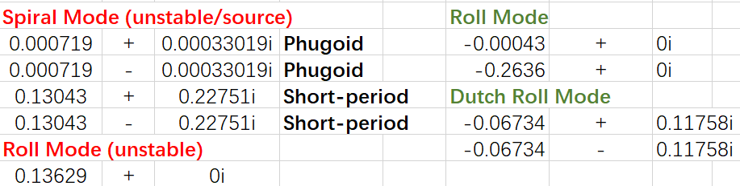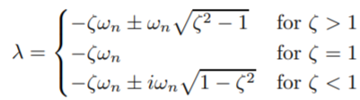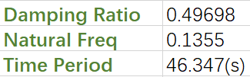

Figure 1-1. Trim Results (up: trimmed; down: untrimmed)

**2) Roll Mode (stable)**

In the first order system, the roll modes incliding (2 305.5s) and fast roll response (3.7936s)

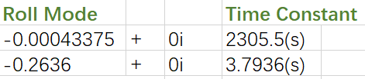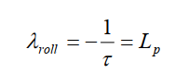

**3) Linearized Matrix Analysis**

From the A matrix linearized from the non-linear system, the Q_dot could never change Q, which may cause lots of problem like we could not control the pitch angle while running the system. In the next section the system would be optimized and re-linearized as to change it’s behavior.

3.3.2 Lateral/Longitudinal Motion Control

For this section, PID controller design is applied to optimize the dutch roll mode parameters for faster rudder response. As we all know, analysis of MIMO (Multiple-input-multiple-output) systems using basic loop shaping techniques, especially for root-locus analysis, requires that only one loop at a time can be closed.

From the figure, the inner loop of [rudder-R] is designed to damp the Dutch Roll Mode and the root-locus could be used for closed loop gain selection due to different damping coefficient.

**1) Relinearized System and Behavior Analysis**

By relinearize the [Rudder-R] system with PID controller and ‘wash out’ blocks, we have A matrix and eigenvalues as the figure shows.

From the eigenvalues distribution graph comparing with rlocus graph, the Dutch roll mode and

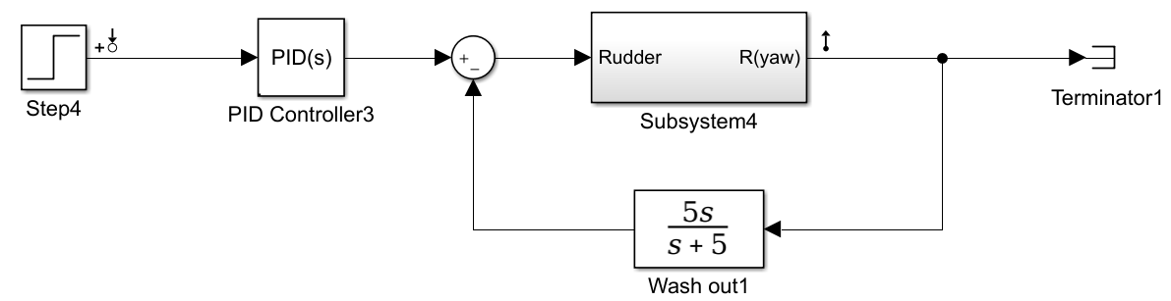

**2) Aero-surface Control**

By adding the first order actuator into the linearized system as the figure below shows, the system yawing angles can respond to the rudder paddle changes in a linearized way.

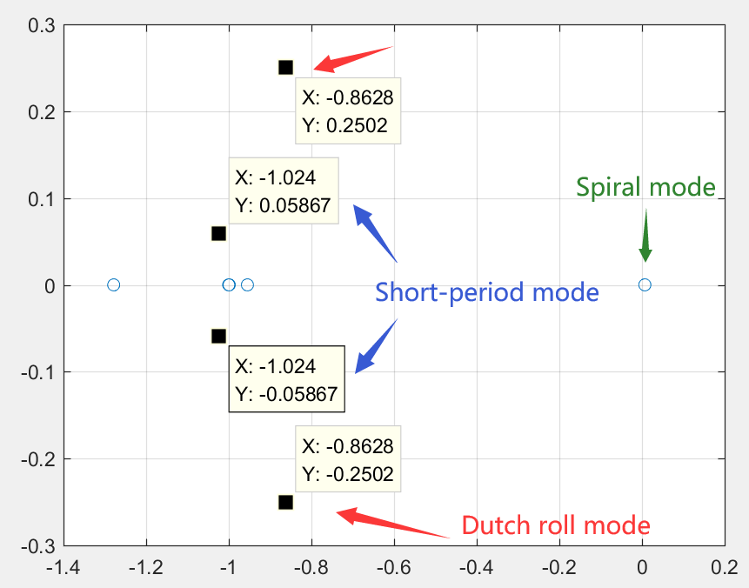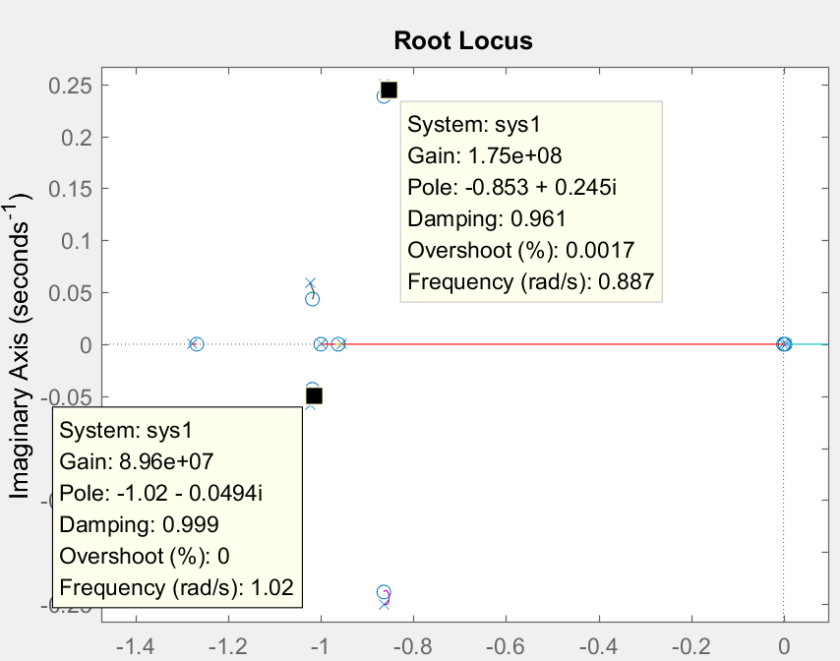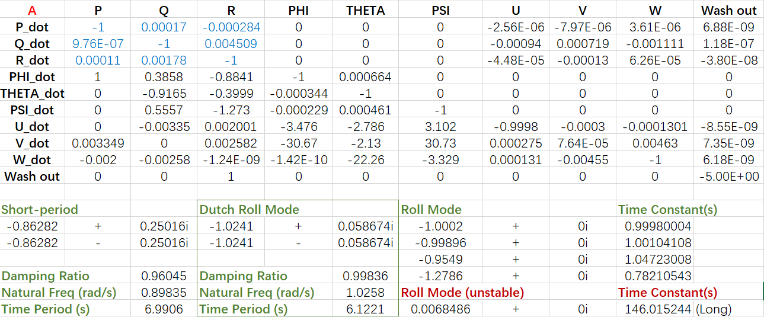

According to the book, much higher gain will demand excessive control deflection rates of rudder and the gain will be designed due to rlocus and multiple tries.

Also from the Bode diagram figure and comparing figure for the [rudder-yaw] the ‘wash out’ as it doesn't contribute much for the performance but adding a roll mode with short time constant (The wash out pole set to be ‘-1’). The outer loop on both sides work as the sensor in deefback loop. From the different Kp applied in the loop, the yawing angle with change along it with different speed.

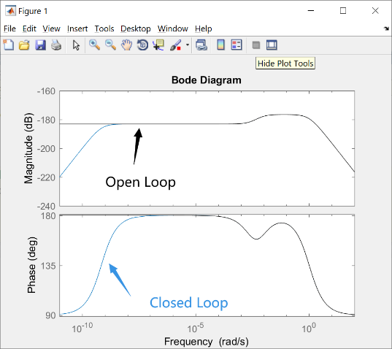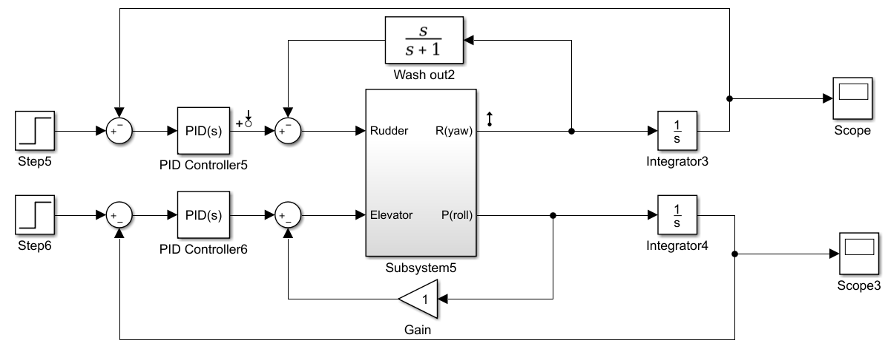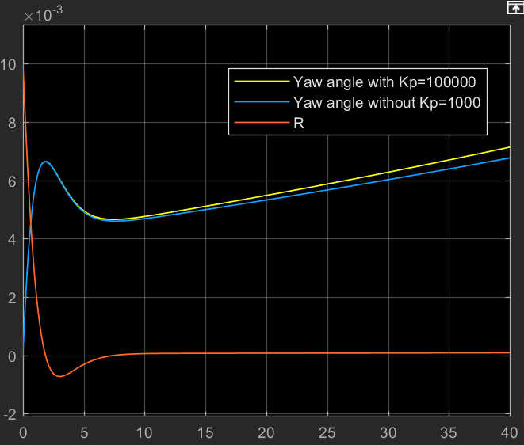

From the comparison of the two linear systems,

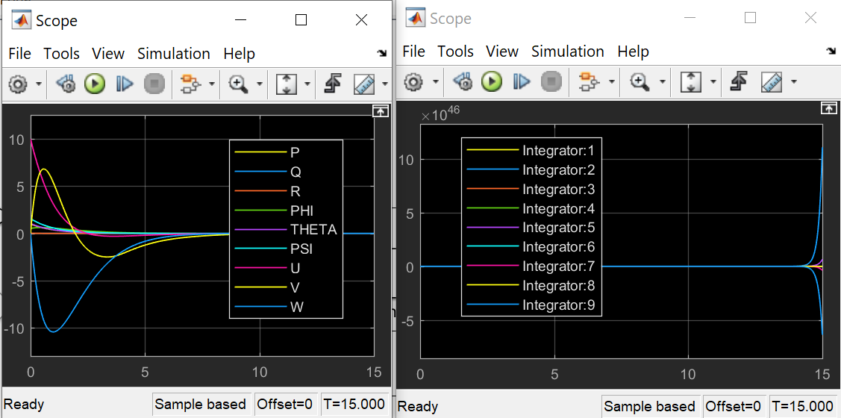

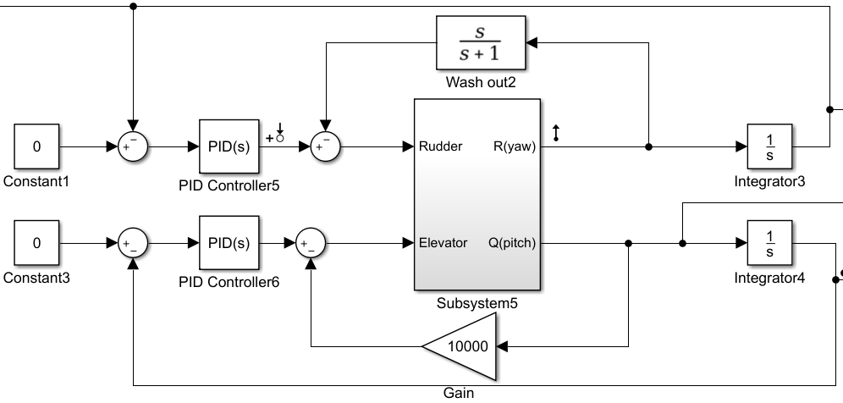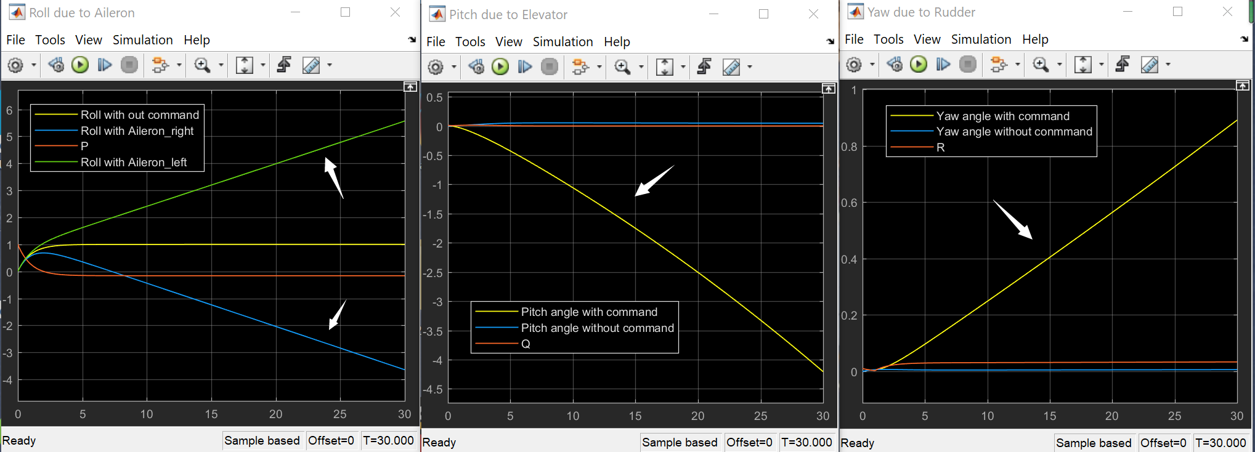

3.3.2 Linear Controller Design

1) Step Input for V

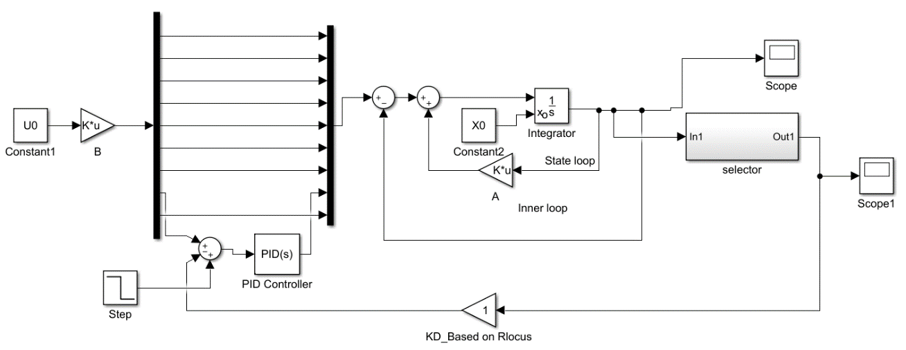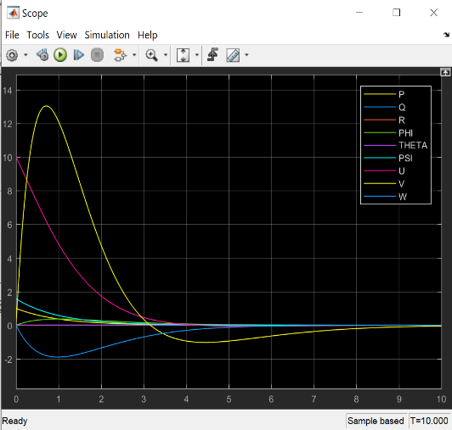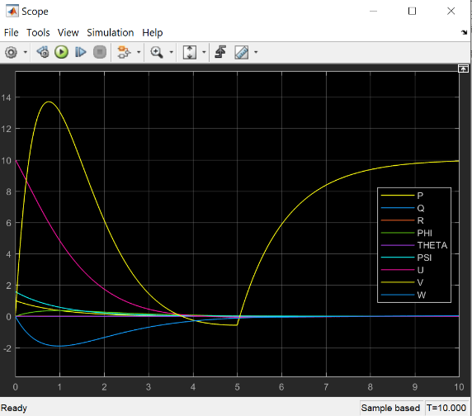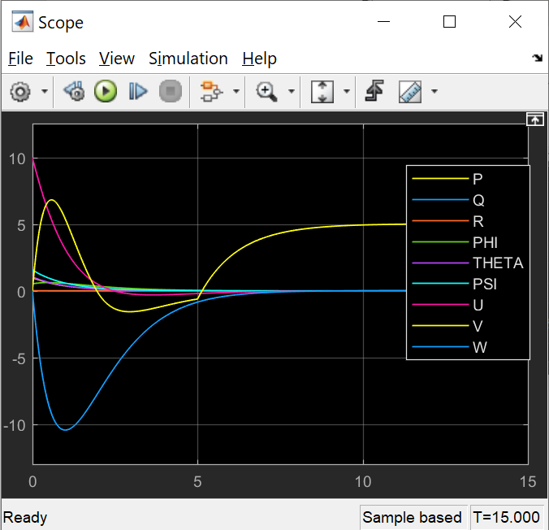

[NO step input][magnitute=10 step time =5] [magnitute=10 step time =5 saturation=5]

2) PID design for V

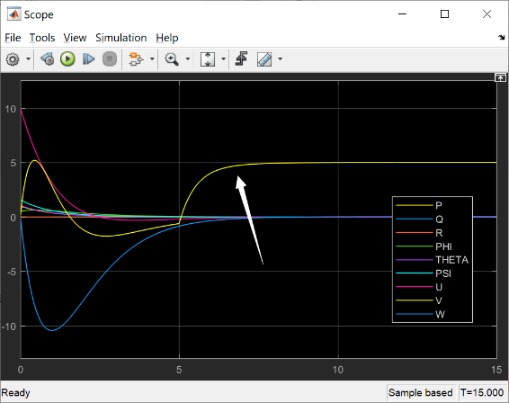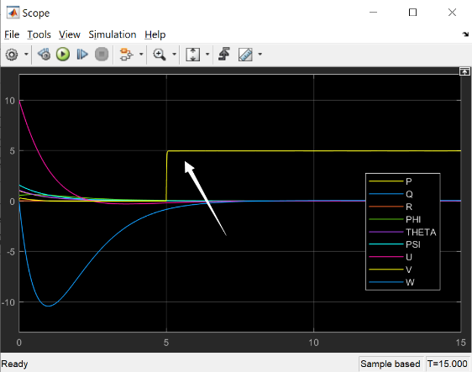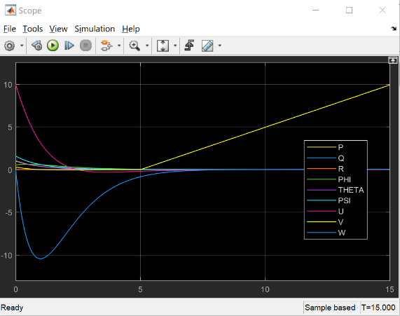

[Kp, Ki, Kd]=[1,0,0] [Kp, Ki, Kd]=[100,0,0] [Kp, Ki, Kd]=[100,0,0]

3) PID design for PHI

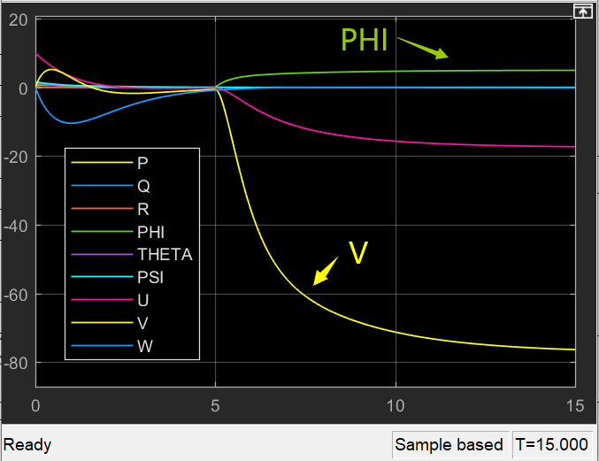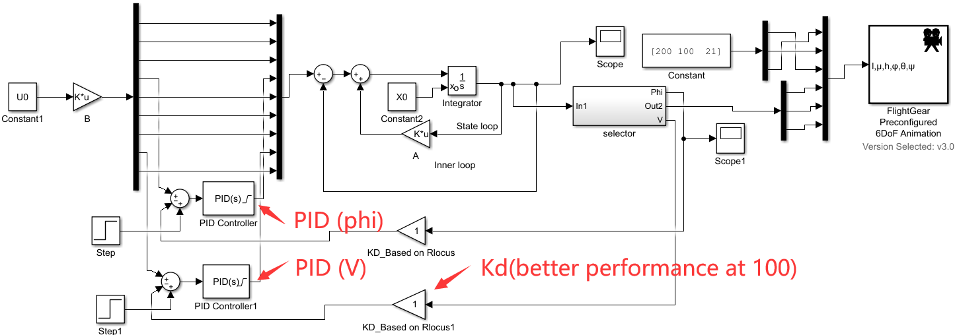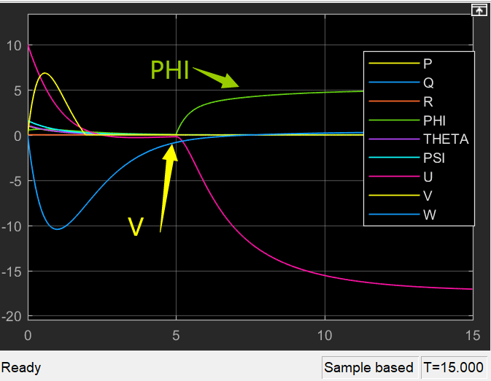

[PID applied to phi] [PID applied to phi and V]

Chapter 4: ASW28 Flight Dynamic Analysis

4.1 Introduction

In this chaptar,

Table-1: Flight Environment Parameters

|  |  |  |  |  |
| --- | --- | --- | --- | --- |
| Model Name | Velocity(m/s) | Temperatue(ºF) | Altitute(m) | Air Density(kg/m^3) |
| ASW28 | 400 | 77 | 1000 | 1.074 |

4.2 XFLR5 Dynamic Analysis

4.2.1 Model Design

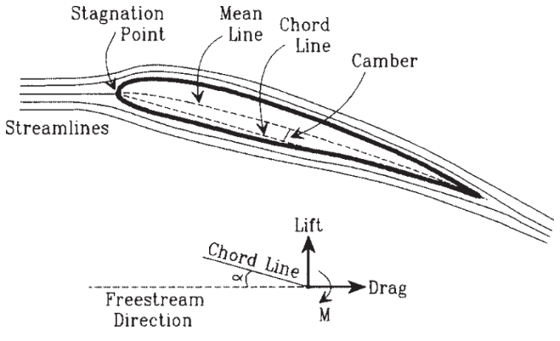

Figure 2.2-1 Definitions associated with an airfoil.

The model uses NACA 2412 data for main wing and elevator section and NACA 0009 for ruder section. By choosing proper sweepback angle and taper, the coefficients change along different alpha degree(-1.5 to 30 [deg])

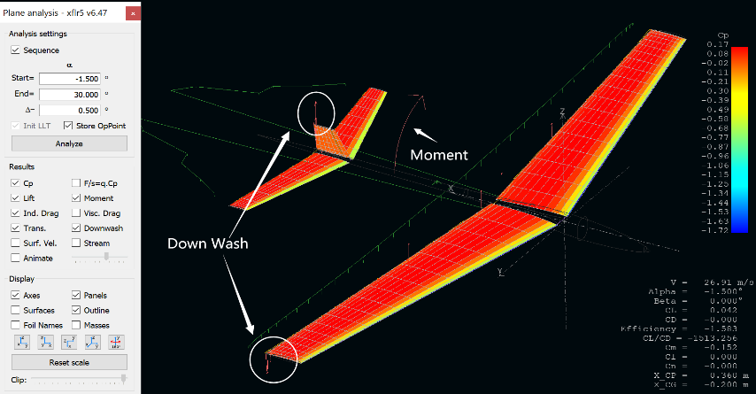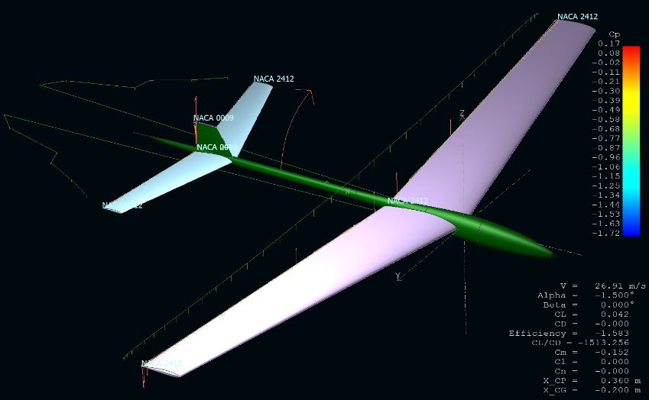

Figure 2.2-1 Definitions associated with an airfoil.

4.2.2 Dynamic Coefficient Calculation

The figure below shows without offset points.

Figure 2.2-1 Definitions associated with an airfoil.

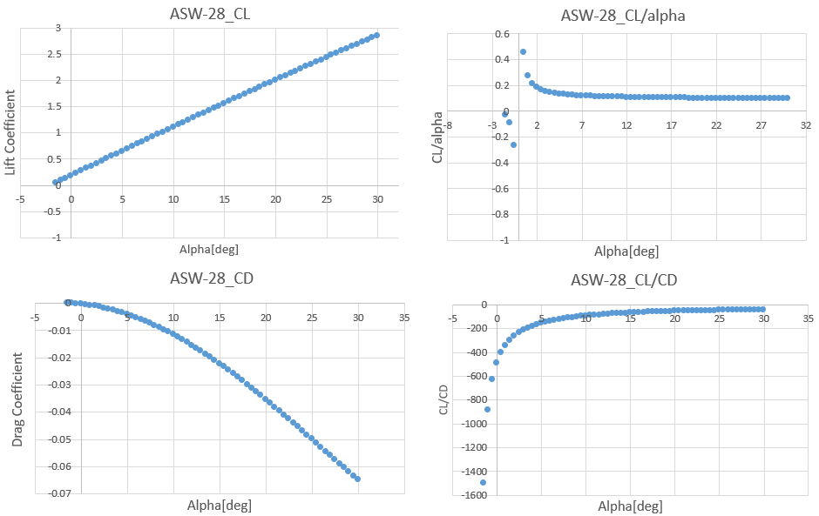

4.3. ANSYS Dynamic Analysis

4.3.1 Finite Element Analysis

By use ANSYS FLUENT module, the FEA analysis is applied to the whole

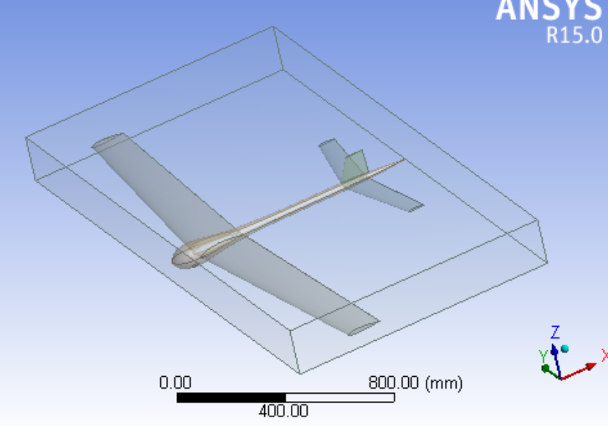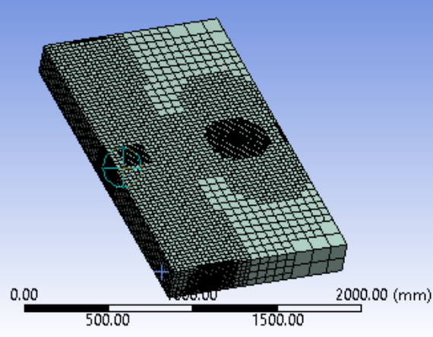

Figure 2.2-1 Definitions associated with an airfoil.

In order to control the variables in two methods, the model imported into ANSYS

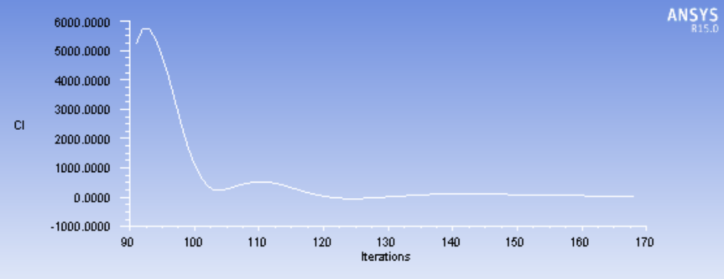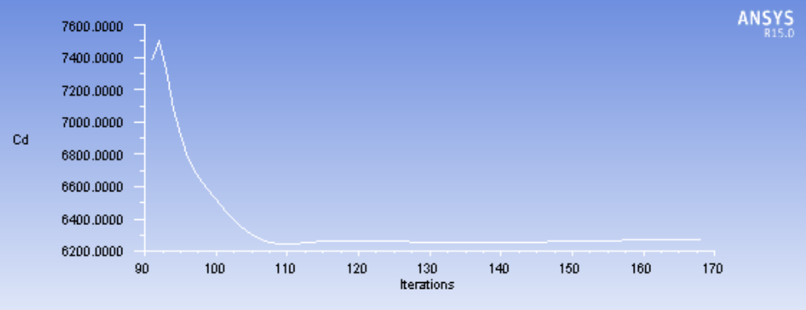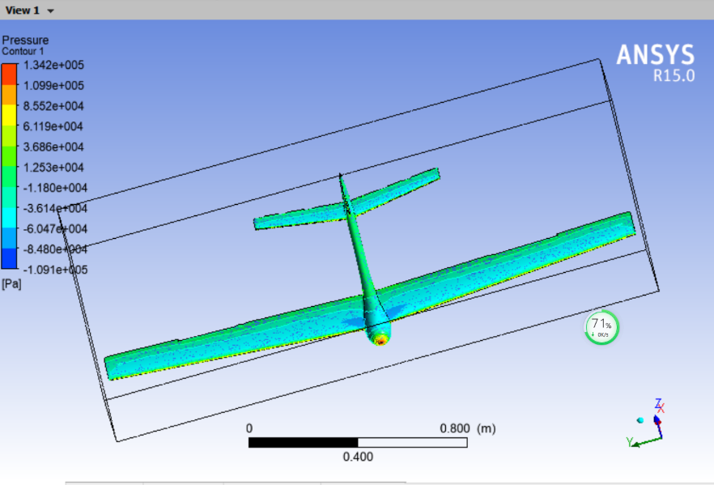

Figure 2.2-1 Definitions associated with an airfoil.

4.4. Results Comparison

4.4.1 Fuselage Analysis

4.4.2 Method Differences

4.4.3 Aerodynamic Parameter Distribution

1) Pressure Distribution

2) Streamline Distribution

4.5 Conclusions

Chapter 5: Simulation

5.1 Connection to FlightGear

The block in aerospace basket is used to conneck MATLAB Simulink to FlightGear

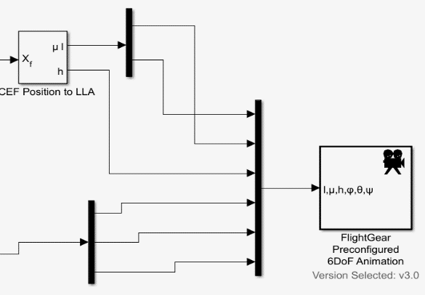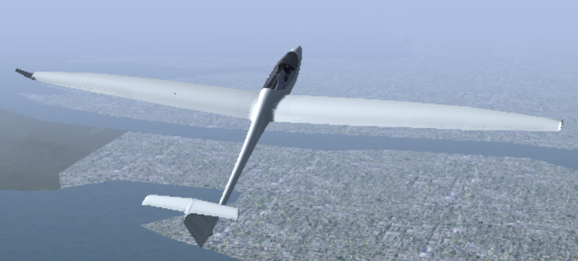

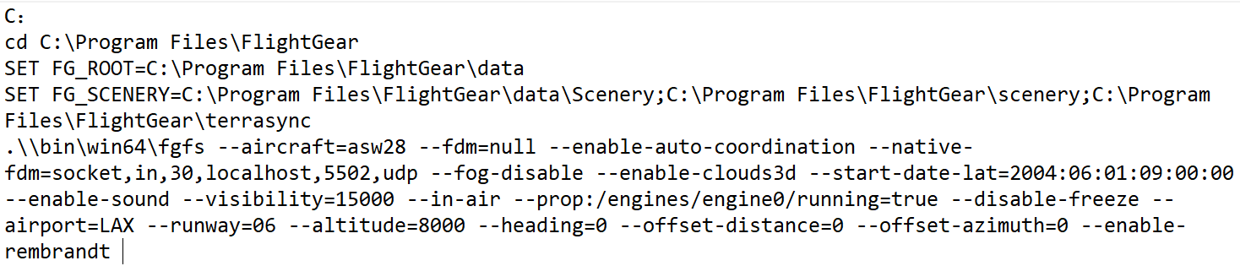

5.2 Lateral/Longitudinal Motion Control

(See the book)

This could be a PID controller with the input from your current roll and a reference of zero. Output should go to your aileron-cmd.

5.3 Skid to Turn

Linear analysis of the system provides a good starting point to consider design modifications that would allow ASW28 to perform skidding turns better.

5.4 Auto pilot

Conclusions

References

[1].STEVENS, B.L., F.L. LEWIS and E.N. JOHNSON, [1] Aircraft Control and Simulation Third Edition Dynamics, Controls Design, and Autonomous Systems, United States of America: John Wiley & Sons, Inc., Hoboken, New Jersey

[2]. Dr. Nelson, R.C., [2] Flight Stability and Automatic Control 2nd Ed.

[3]. Kaloust, J., C. Ham and Z. Qu, [3] Nonlinear autopilot control design for a 2-DOF helicopter model.

[4]. Chen, C., [4] System Theory and Design. Second Edition ed: Oxford University Press.

[5]. Yechout, T.R., et al., [5] Introduction to aircraft flight mechanics: American Institute of Aeronautics and Astronautics, Inc.1801 Alexander Bell Drive, Reston, VA 20191-4344.

[6]. Michael Basler, M.S., et al., [6] The FlightGear Manual for FlightGear Version 3.6.0.

[7]. Chambers, J.R. and R.M. Hall, [7] Historical Review of Uncommanded Lateral-Directional Motions at Transonic Conditions. JOURNAL OF AIRCRAFT, (Vol. 41, No. 3, May–June 2004).

[8]. Rauf, A., et al. [8] Aerodynamic modeling and state-space model extraction of a UAV using DATCOM and Simulink. 2011: IEEE.

[9]. Rysdyk, R., [9] Course and Heading Changes in significant wind. JOURNAL OF GUIDANCE, CONTROL, AND DYNAMICS, (Vol. 30, No. 4, July–August 2007).

[10].Kubica, F. and T. Livet, [10] Flight Control Law Synthesis for A Flexible Aircraft. American Institute of Aeronautics, 1994.

Useful links

How to dynamically change a block parameter value during simulation run-time?

<https://www.mathworks.com/matlabcentral/answers/334224-how-to-dynamically-change-a-block-parameter-value-during-simulation-run-time>

<https://www.mathworks.com/help/releases/R2017a/simulink/ug/using-tunable-parameters.html>

<https://uk.mathworks.com/help/simulink/ug/tune-and-visualize-your-model-with-dashboard-blocks.html>

Send fdm to flightgear

<https://www.mathworks.com/help/aeroblks/sendnet_fdmpackettoflightgear.html>

<https://www.mathworks.com/help/aeroblks/sendnet_fdmpackettoflightgear.html>

<https://www.mathworks.com/help/aeroblks/packnet_fdmpacketforflightgear.html>

<https://www.youtube.com/watch?v=jB-80cvV1Ao>

<https://forum.flightgear.org/viewtopic.php?f=36&t=32707>

<https://www.mathworks.com/help/aeroblks/packnet_fdmpacketforflightgear.html>

S function/UDP

<https://www.mathworks.com/help/simulink/sfg/sim-viewing-devices-in-external-mode.html>

<https://www.mathworks.com/help/simulink/sfg/example-of-a-basic-c-mex-s-function.html#f8-82449>

<https://www.mathworks.com/help/aeroblks/packnet_fdmpacketforflightgear.html>

<https://www.mathworks.com/matlabcentral/answers/309926-matlab-udp-recieve-error>

Simulink Animation

<https://www.mathworks.com/videos/modeling-simulation-and-flight-control-design-of-an-aircraft-with-simulink-81546.html>

<https://www.mathworks.com/products/aerospace-toolbox.html>

ANSYS FLUENT

<https://www.youtube.com/watch?v=2x1Qx15pzm0>

<https://www.youtube.com/watch?v=HGzcVkDPHe4>

<https://www.youtube.com/watch?v=kuEqlSmyAos>

MODEL ASW28 to FG

<https://www.youtube.com/watch?v=Wb9bzS80ThA>

<http://wiki.flightgear.org/Blender_AC3D_import_and_export>

SOLIDWORKS

<https://www.youtube.com/watch?v=2iE_zo16bWM>

<https://www.youtube.com/watch?v=c_QEEPGUxDg>

<https://www.youtube.com/watch?v=aT9z-D_dwU4>

Controller design

<https://www.mathworks.com/videos/pid-control-made-easy-81646.html>

<https://www.mathworks.com/videos/trim-linearization-and-control-design-for-an-aircraft-68880.html>

<https://www.youtube.com/watch?v=LzQPJRt00Ng>

<https://www.mathworks.com/videos/automatic-tuning-of-a-helicopter-flight-control-system-90590.html>

<https://www.mathworks.com/videos/linear-system-analysis-in-simulink-81587.html>

<https://www.youtube.com/watch?v=CJGlKCfGEA0>

AutoPilot Design

<http://wiki.flightgear.org/Howto:Design_an_autopilot>

Linmod()

<https://www.mathworks.com/help/slcontrol/ug/linearize-at-trimmed-operating-point.html>

<https://www.mathworks.com/help/slcontrol/ug/linearize-simulink-model.html>

<https://www.mathworks.com/help/slcontrol/ug/specify-model-portion-to-linearize.html>

<https://www.mathworks.com/help/slcontrol/ug/linearize-at-simulation-snapshot.html>

<https://www.mathworks.com/videos/linear-system-analysis-in-simulink-81587.html>

<https://www.mathworks.com/help/slcontrol/ug/linearize-simulink-model.html>

Eigenvalue behaviors

<http://www.sosmath.com/diffeq/system/linear/qualin/qualin.html>

<https://courses.cit.cornell.edu/mae5070/DynamicStability.pdf>

<http://www.dept.aoe.vt.edu/~lutze/AOE3134/AircraftDynamics.pdf>